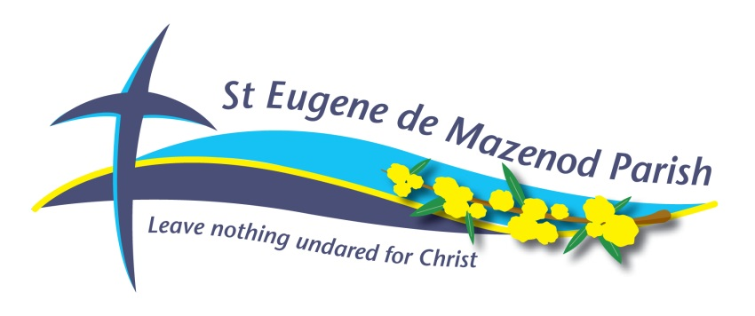

(Under The Pastoral Care of the Missionary Oblates of Mary Immaculate)

Churches: St. Eugene de Mazenod Church

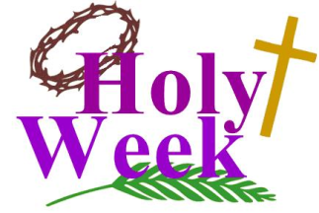
Springfield Drive, Burpengary
Christ the King Church

54 Thompson Street, Deception Bay

Parish Priests: Fr. David Francis O.M.I., Fr Brian Harris O.M.I.

HOLY WEEK CELEBRATIONS

Palm Sun 14th April Masses as normal
Mon 15th April 9.00 a.m. Mass – CTK Church
Tues 16th April 9.00am Mass – St Eugene
Wed 17th April 9.00 am Mass – CTK Church

Holy Thu 18th April NO 9.00am Mass
7.00pm Mass of the Lord’s Supper - CTK Church
followed by reconciliation / silence until 9.00pm

Good Fri 19th April NO 9.00am Mass
9.30am Morning Prayer of the Church - St Eugene Church
10.00am Outdoor Stations of the Cross - St Eugene Church
until 12.00pm Reconciliation
3.00pm Liturgy of The Lord’s Passion - St Eugene Church
until 4.45pm Reconciliation

Holy Sat 20th April 9:00 a.m. Morning Prayer of the Church - St Eugene Church
10.00am Reconciliation - St Eugene Church
6.30pm Easter Vigil - St Eugene Church

Easter Sun 21st Apr 7.30am Mass - Christ the King Church
9.30am Mass - St Eugene Church
PLEASE NOTE: NO EVENING MASS

Sun 28th April 2.00pm Divine Mercy Celebrations – St Eugene Church

